**The Basics of MyPlate**

**Directions:** Identify the five food groups in the place setting & the recommended servings for a ***2000*** calorie diet. Then name a food in the food group and identify ***2*** of the nutrient we get from the food group. Color in the correct color of each section of MyPlate on the outside edge of the plate and cup. Use the lines dividing the food groups inside the plate to color in yellow for fats and sugars.

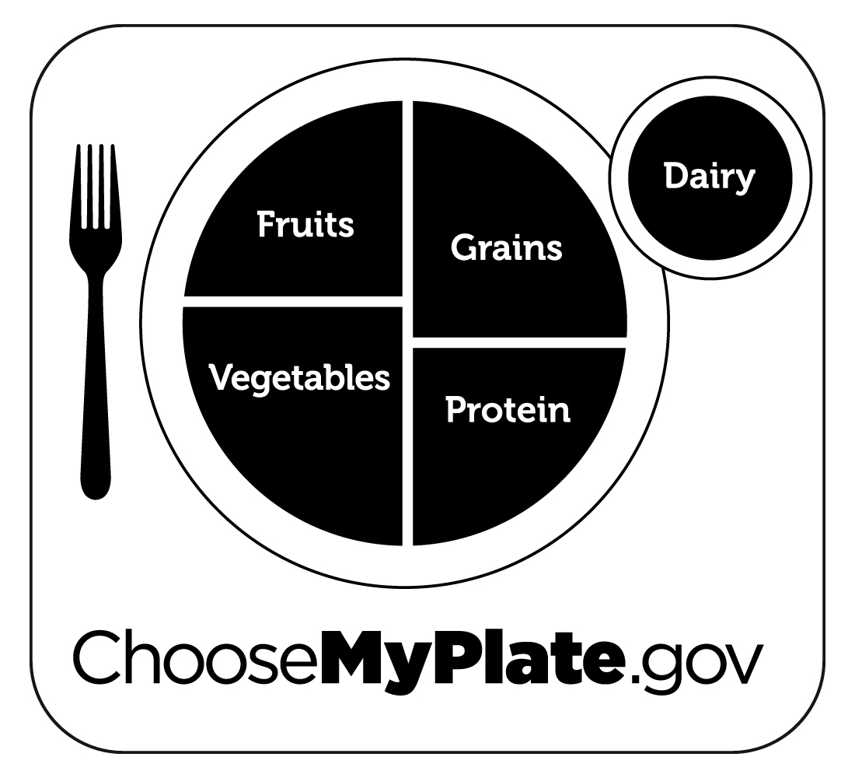

5.od Group_____________

Serving________________

Name a food_____________

Nutrient_____________

2.

Food Group______________

Serving ________________

Name a food_____________

Nutrient_____________

3.

Food Group____________

Serving_______________

Name a food___________

Nutrient_____________

4.

Food Group_____________

Serving________________

Name a food_____________

Nutrient_____________



1.

Food Group______________

Serving ________________

Name a food_____________

Nutrient_____________

5.

Food Group_____________

Serving________________

Name a food_____________

Nutrient_____________

4.

Food Group_____________

Serving________________

Name a food_____________

Nutrient_____________